**Photo Filters**

**Black & White**

Original

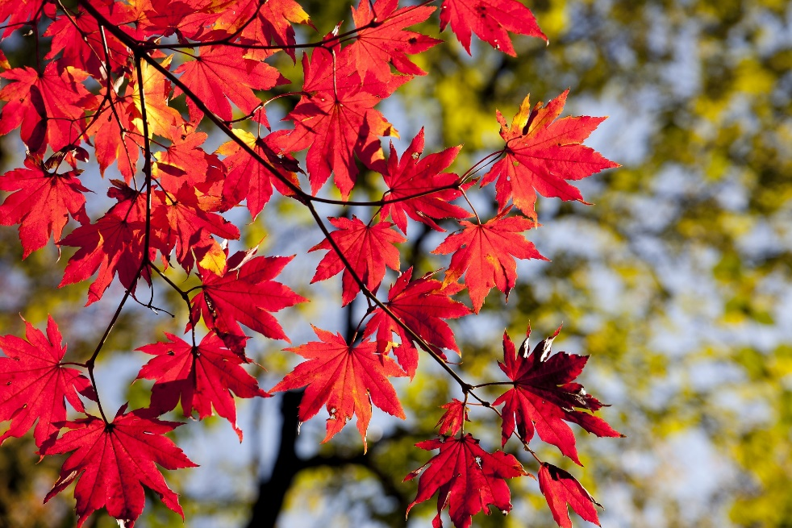

Processed

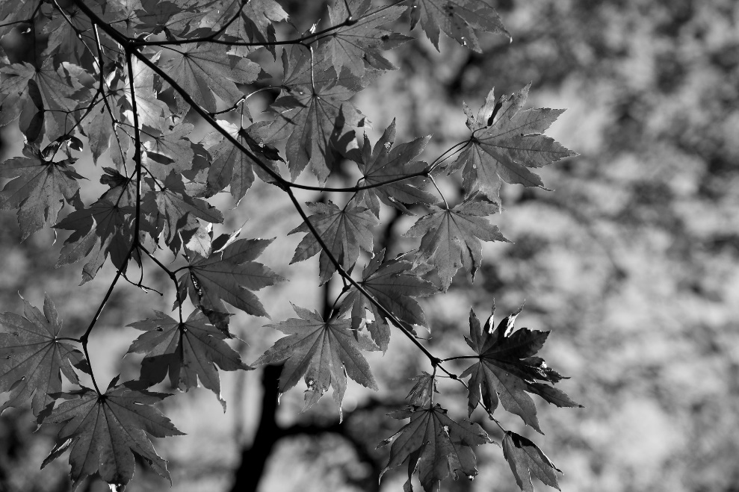

Theory :- Using PIL Python library We extracted pixels from image and then extracted RGB values from pixels

To convert to grayscale formula is

gray=R+G+B/3

i.e. average

put this gray values to every RGB value of every pixel to get this image

*Program:*

*def black_white():*

*new=create_image(width,height)*

*pixels=new.load()*

*for i in range(width):*

*for j in range(height):*

*pixel=get_pixel(im,i,j)*

*red=pixel[0]*

*green=pixel[1]*

*blue=pixel[2]*

*gray=(red*0.299)+(green*0.587)+(blue*0.114)*

*pixels[i,j]=(int(gray),int(gray),int(gray))*

*new.save("output.jpg",'png')*

From this Example you can see other function and its working in func.py file

Red extract

Original

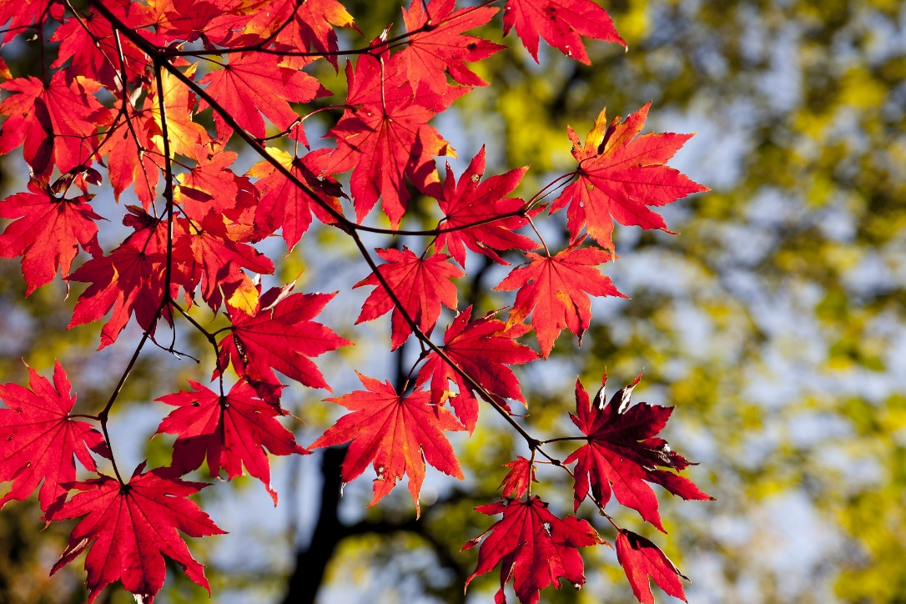

Processed

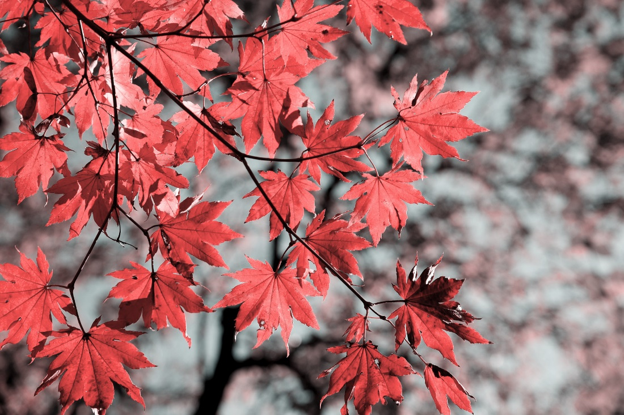

Blue extract

Original

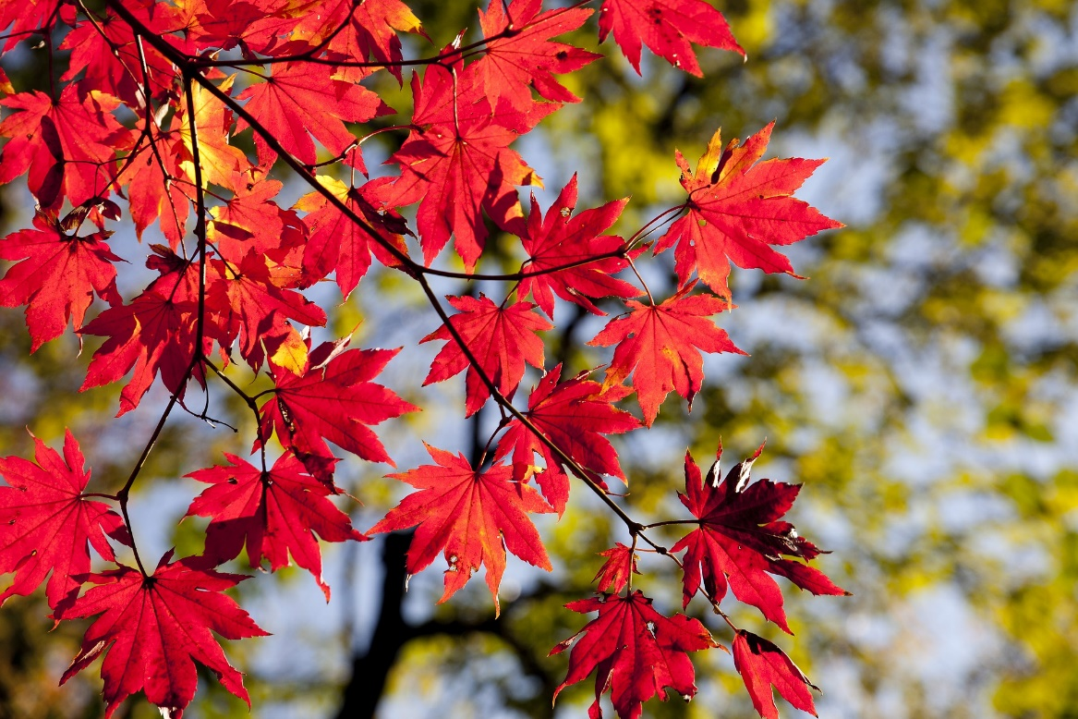

Processed

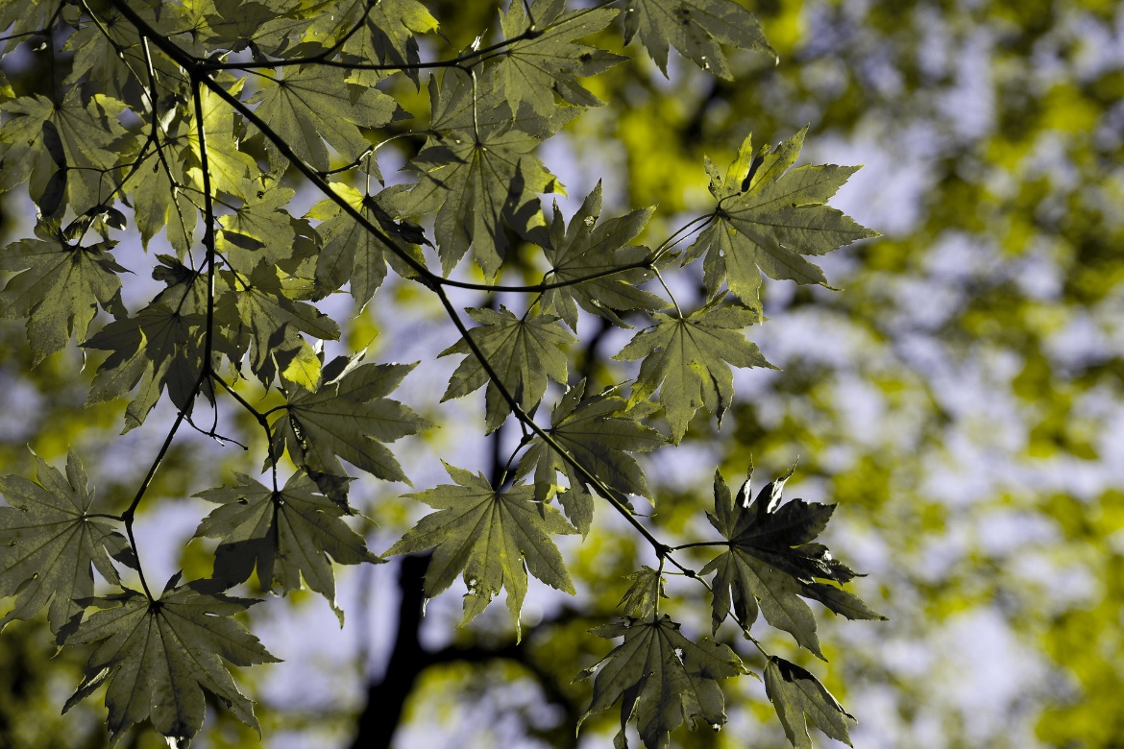

Green extract

Original

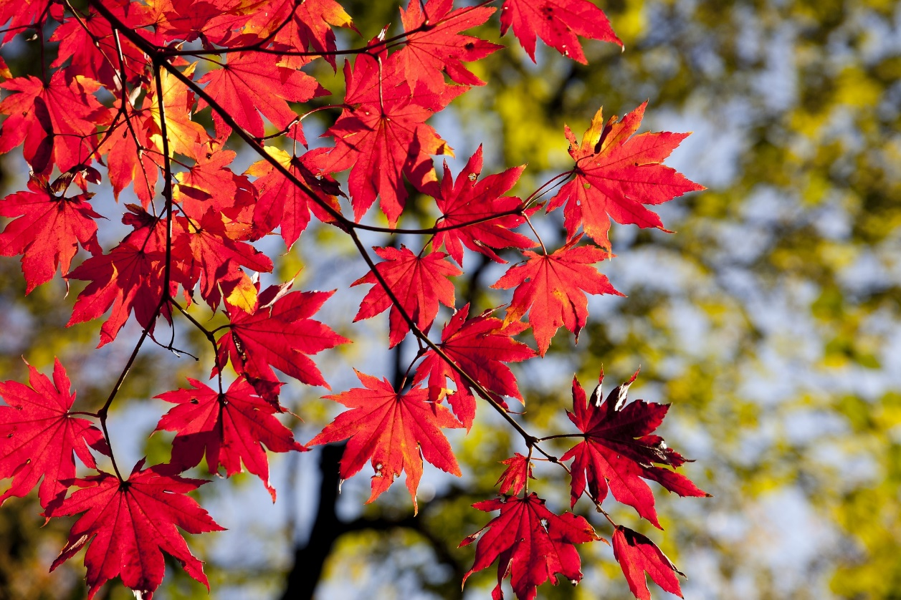

Processed

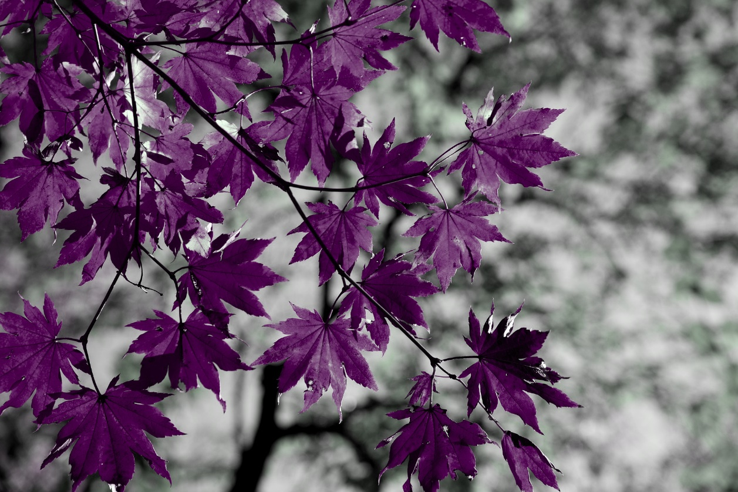

Red

Original

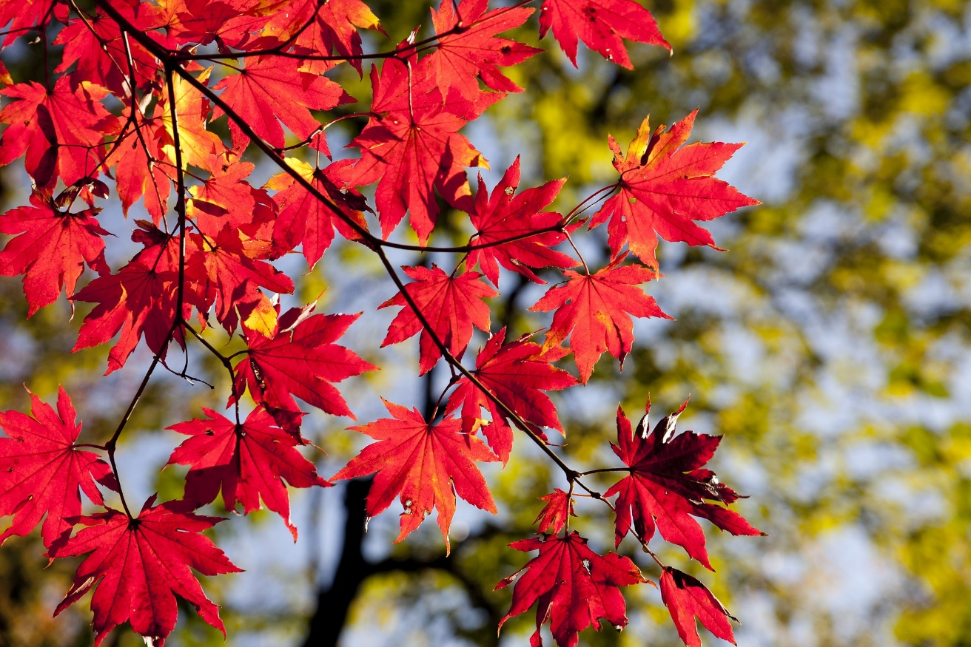

Processed

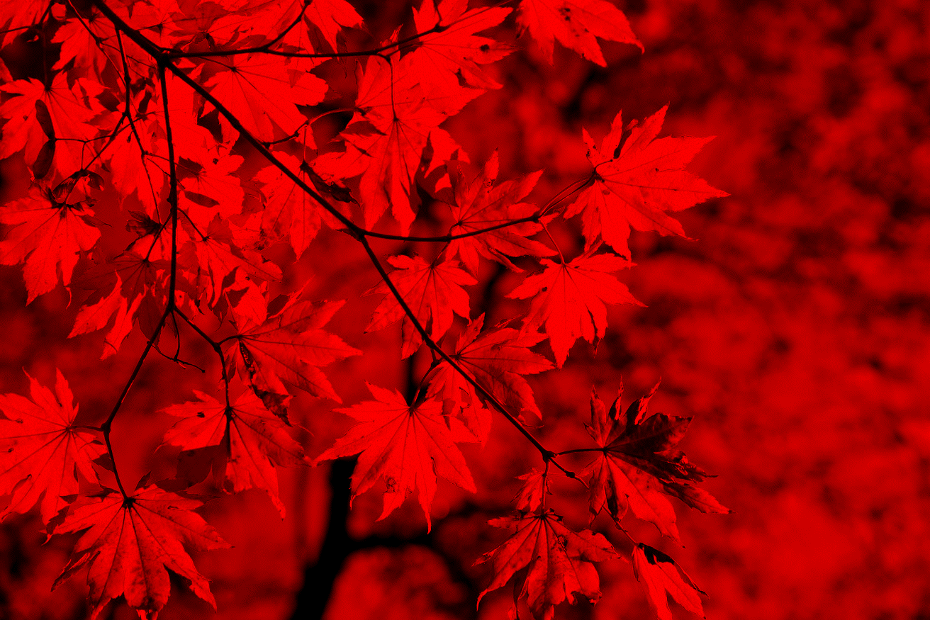

Blue

Original

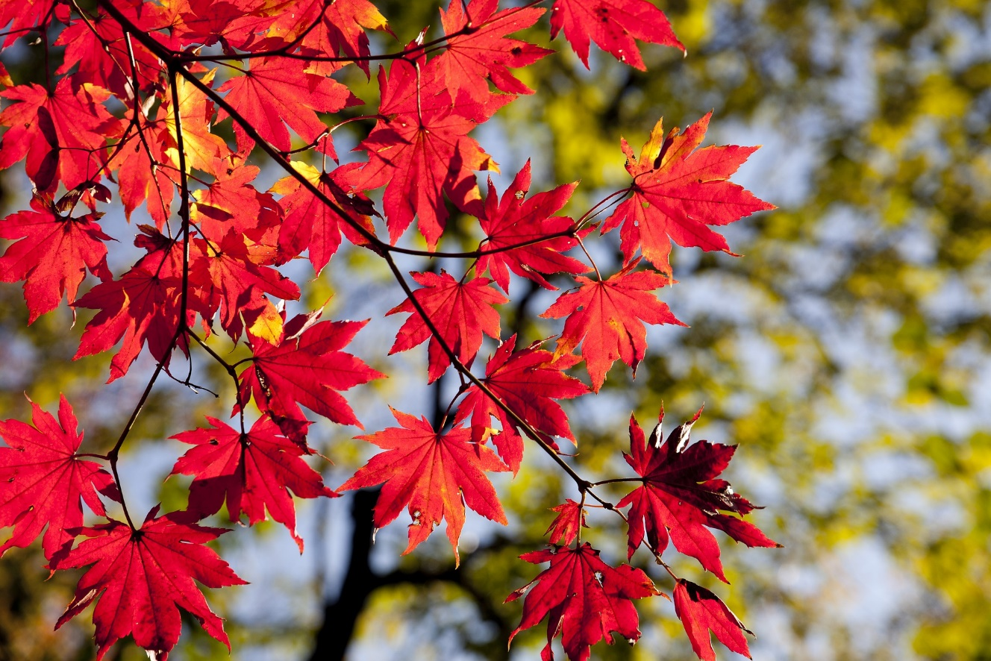

Processed

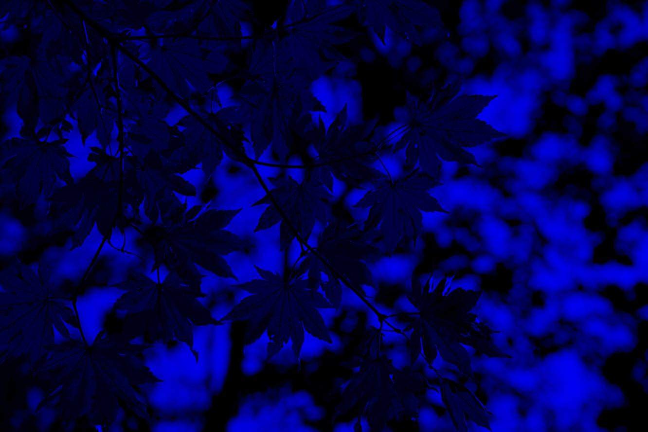

Green

Original

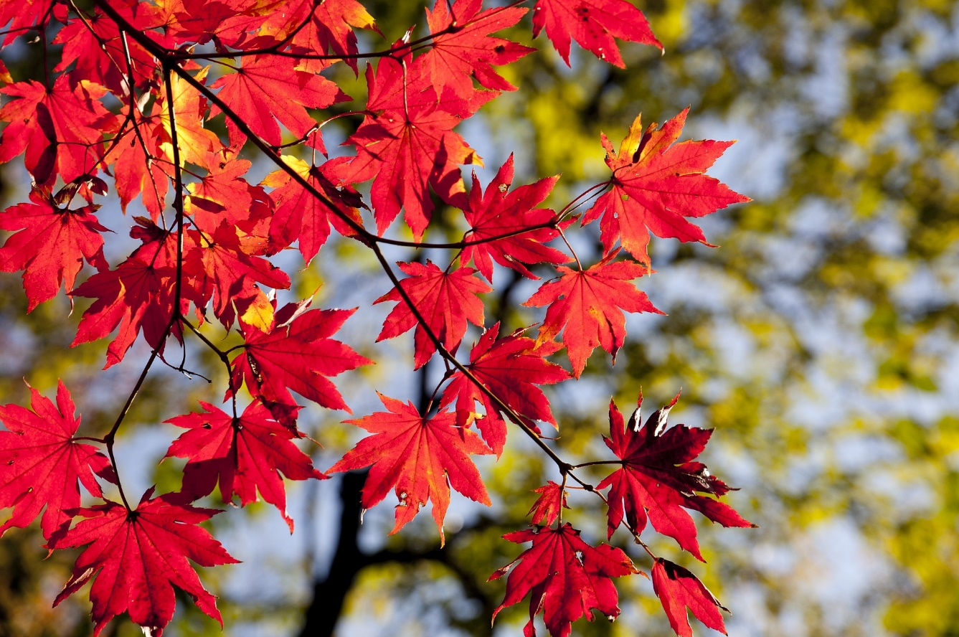

Processed

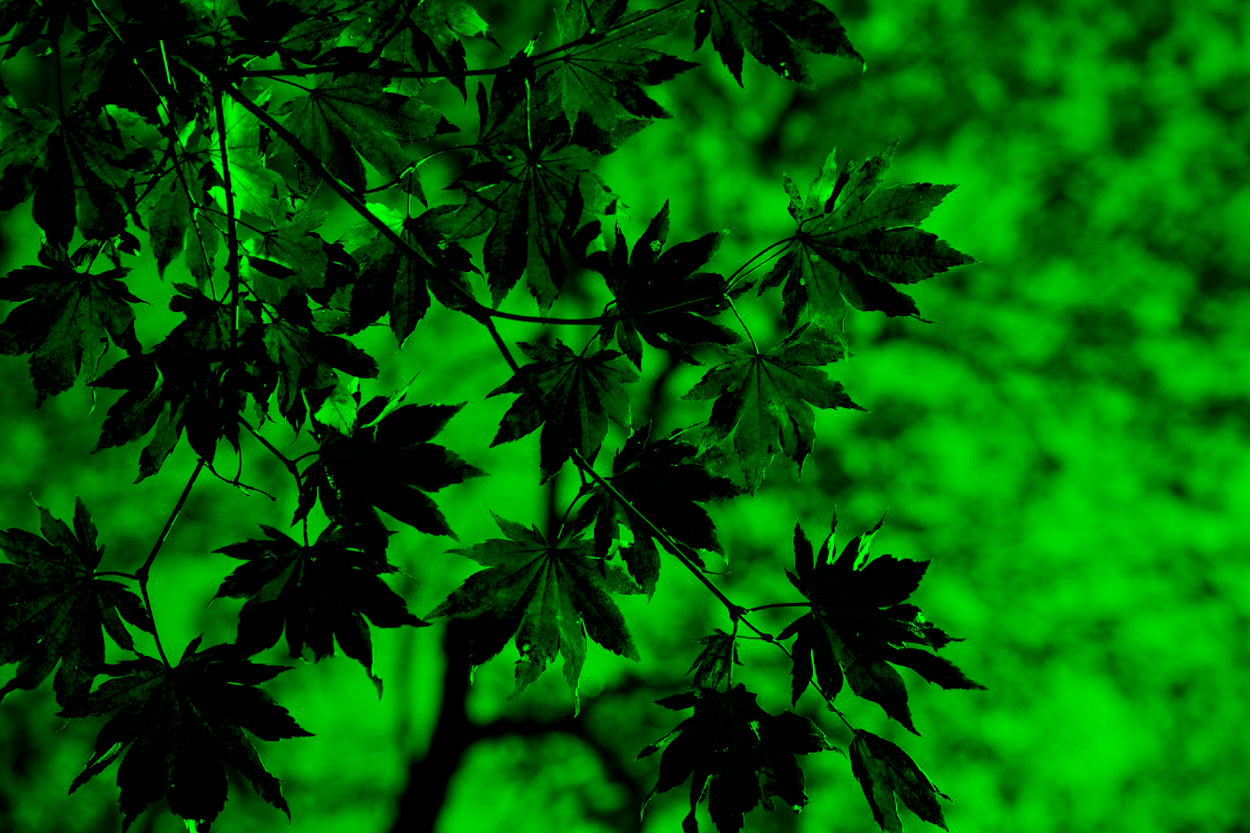

Brightness

Low(k=0.2)

Original

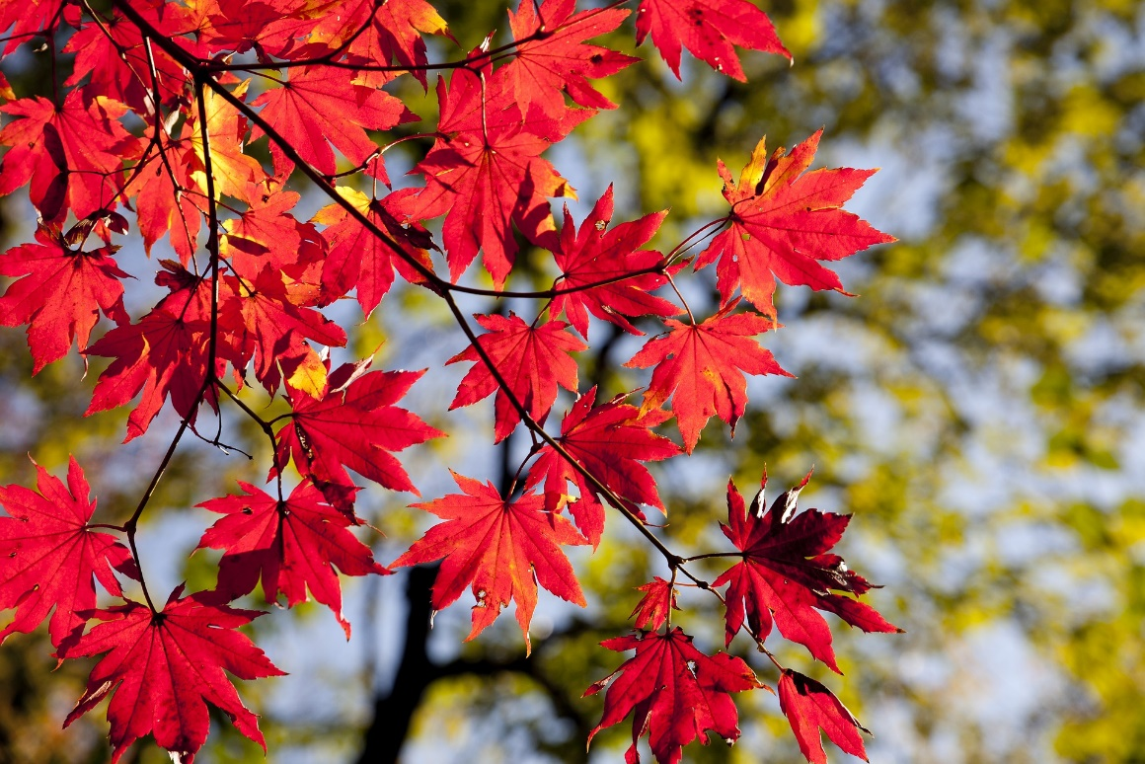

Processed

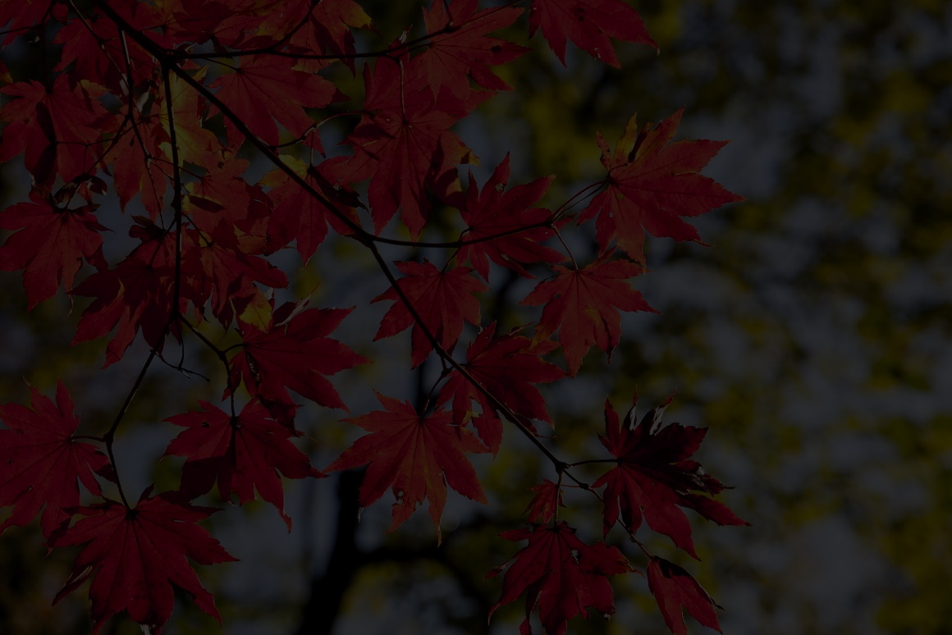

High(k=1.3)

Original

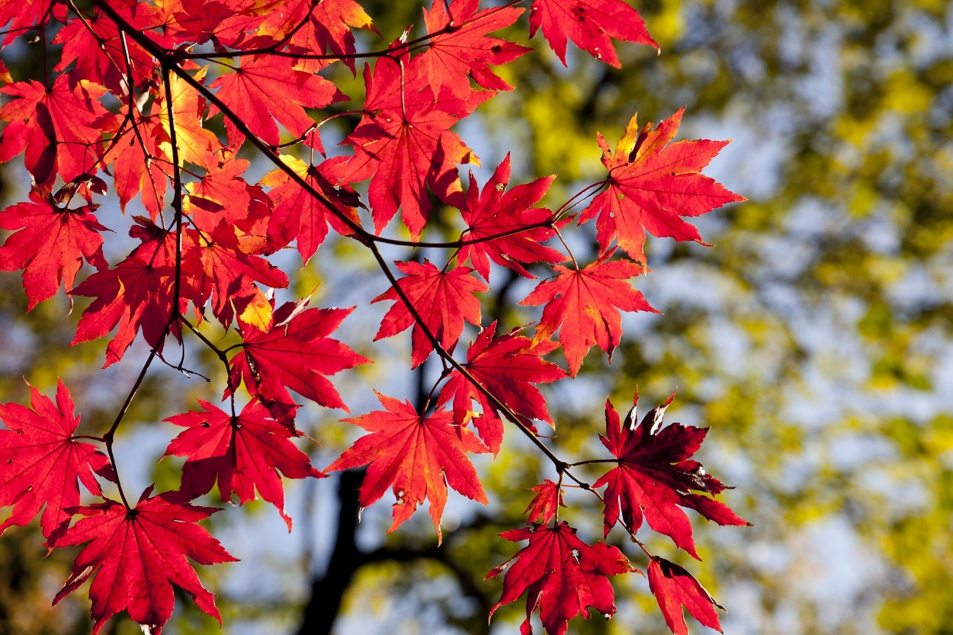

Processed

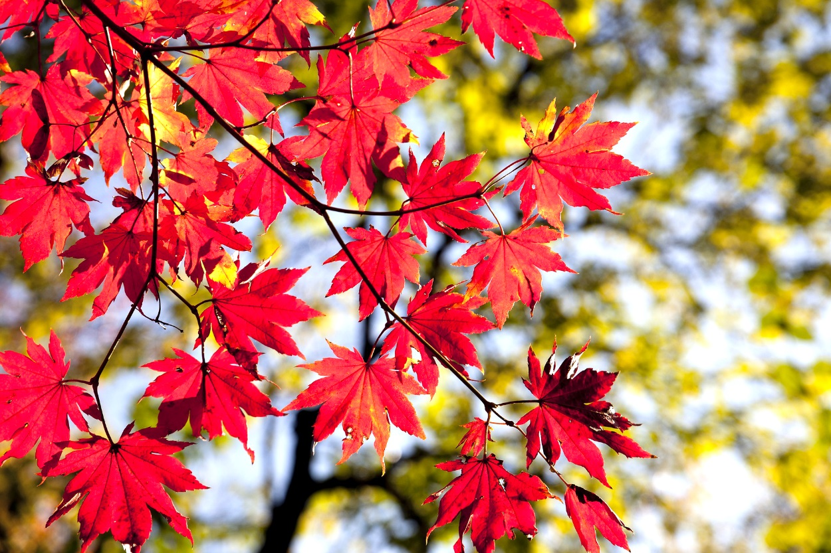

Theory

If we multiply any number with red green blue respectively it will result in change in brightness and if we multiply value k>1 then brightness will increase and if we multiply by k<1 then brightness will decrease